**Unit: Manual Motor Controls Quiz: 7**

**Three Phase Motors and Motor Starters CLO#: 1**

Name ______________________________ Date ______________

**Instructions**

Answer each question to the best of your ability.

1. What article of the NEC covers motor information?
2. In a single-phase system, how many degrees are there between each sine wave?
3. In a split-phase system, how many degrees are there between each sine wave?
4. In a three-phase system, how many degrees are there between each sine wave?
5. List three general types of three-phase motors.
6. What is the purpose of the laminated iron plates within the rotor?
7. If a motor has an enclosure type of ODP, what does that indicate?
8. When a motor has an enclosure type of TEFC, that indicates that it is;
9. A motor has an enclosure type of TENV, what type of environment would it be used?
10. What type of motor would you use at Laclede Gas to pump natural gas?
11. A continuous duty cycle motor can operate at its rated HP for at least;
12. The locked rotor code letter and the NEMA design code letter indicate the same characteristic about a motor?
    1. True
    2. False
13. Why would it be good the select a motor that has a SF > 1?
14. What is the effect of operating a motor above its HP but within its SF?
15. What is motor Efficiency?
16. If a motor is not continuous duty, it is designated as?
17. When a motor is rated for inverter duty, what does that indicate?
18. A motors *Power Factor (PF)* is useful to determine

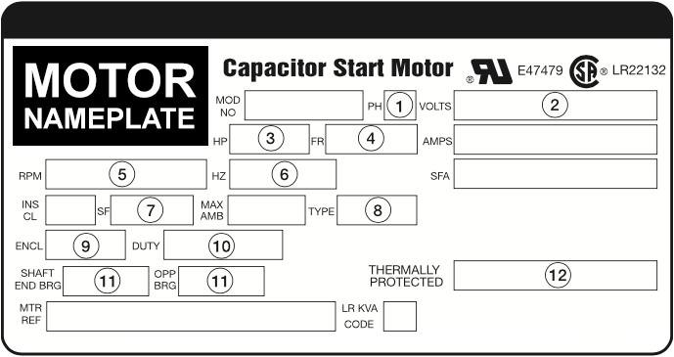

1. TEFC _______
2. How long the motor can run _______
3. Three-Phase Motor _______
4. Shaft Speed _______
5. Applied Power _______
6. 145˚C _______
7. Service Frequency _______
8. Motor’s Construction _______
9. Output Power _______
10. Draw a schematic for a 480V three-phase motor that is controlled by a motor starter. (three-phase portion only)
11. Construct the truth table, formula and state the type of logic for the control schematic below.



1. Construct the truth table, formula and state the type of logic for the control schematic below.



1. Construct the truth table and formula for the control schematic below.

